

**Institute of Technology of Cambodia**

**Department of Information Communication Engineering**

**Subject: Internet Programming**

**Lecturer: HOK TIN**

**TP5**

Name: Doeurn Sreynith

ID: e20190214

Group: GIC-A

**2022-2023**

Contents

Ex1: 3

Ex1-OUTPUT: 8

Ex2: 9

Ex2-OUTPUT: 11

EX3: 12

Ex3-OUTPUT: 16

EX4: 17

Ex4-OUTPUT: 19

EX5: 21

CSS-EX5: 23

EX5-view: 24

Ex5-OUTPUT: 26

# Ex1:

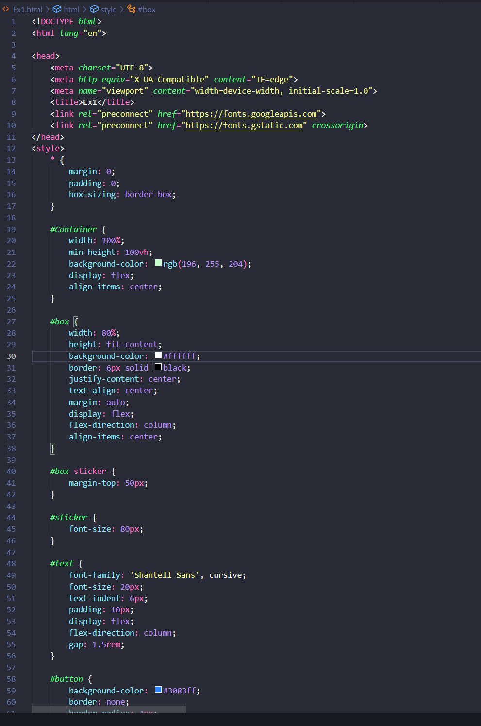

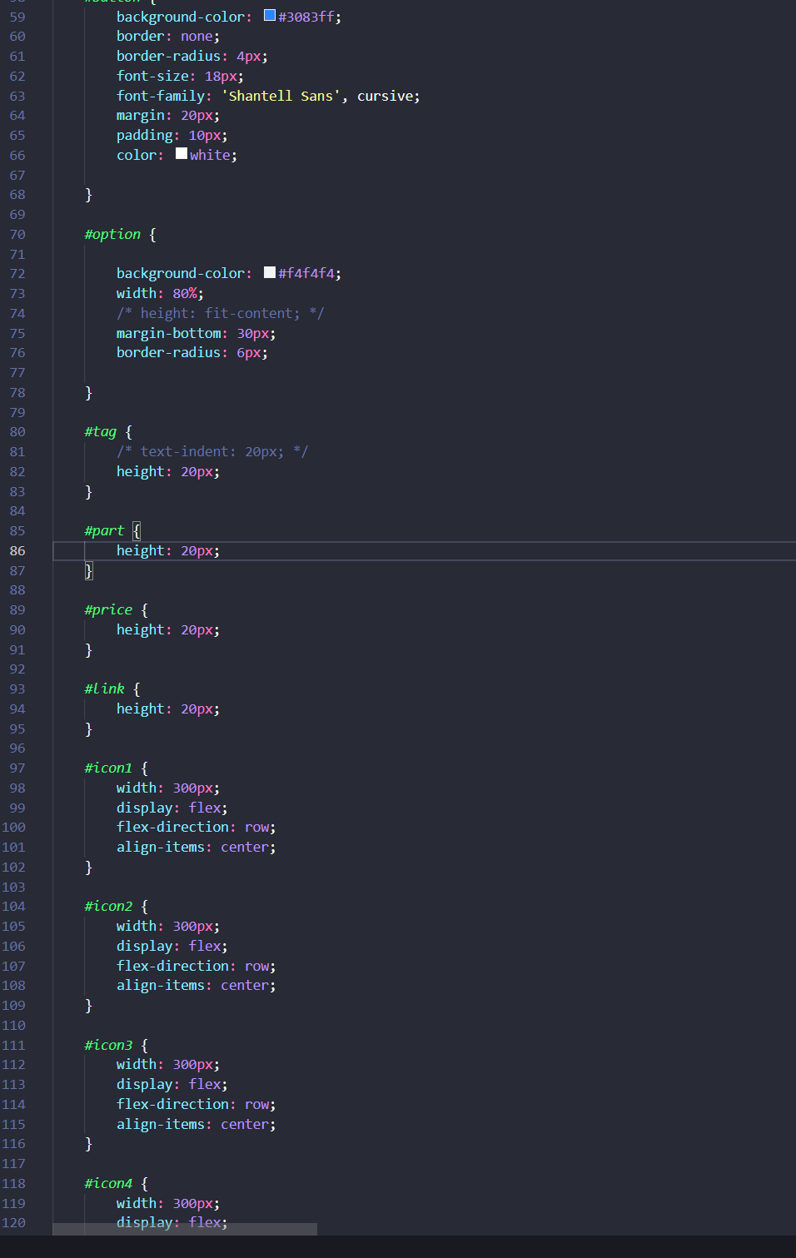

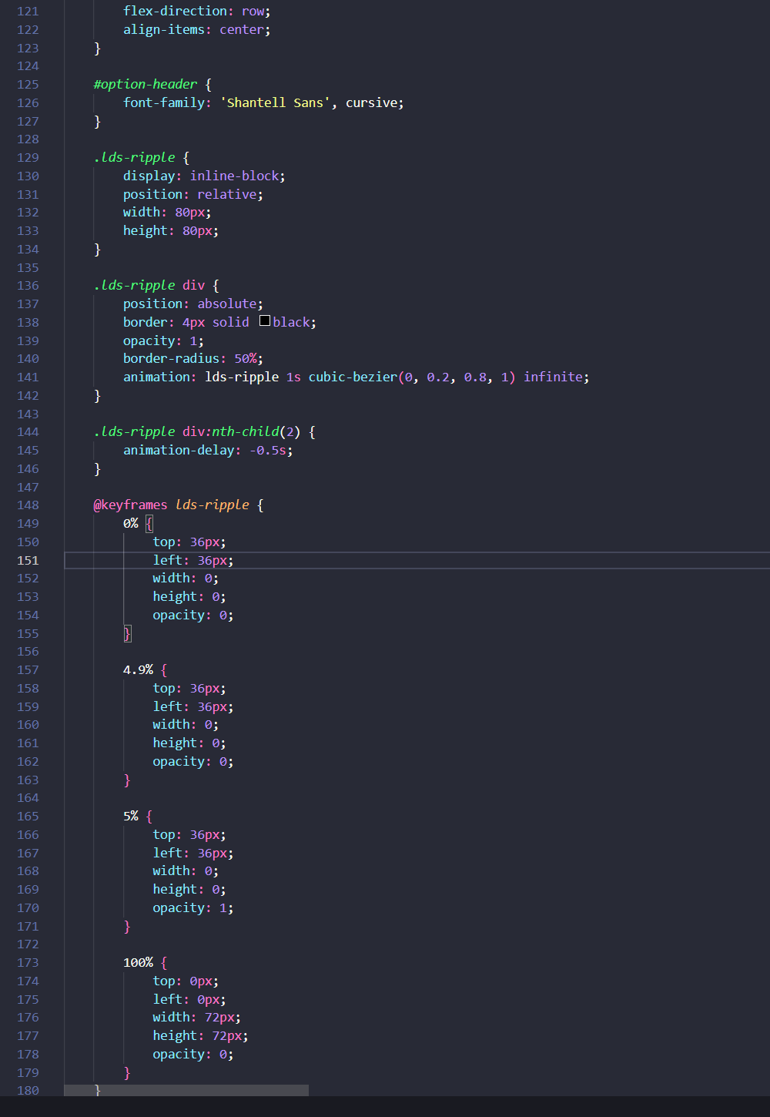

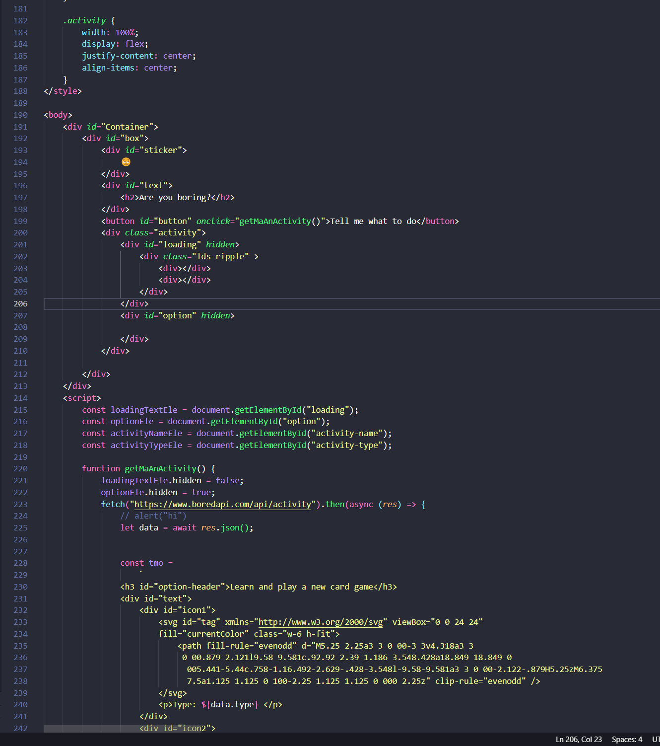

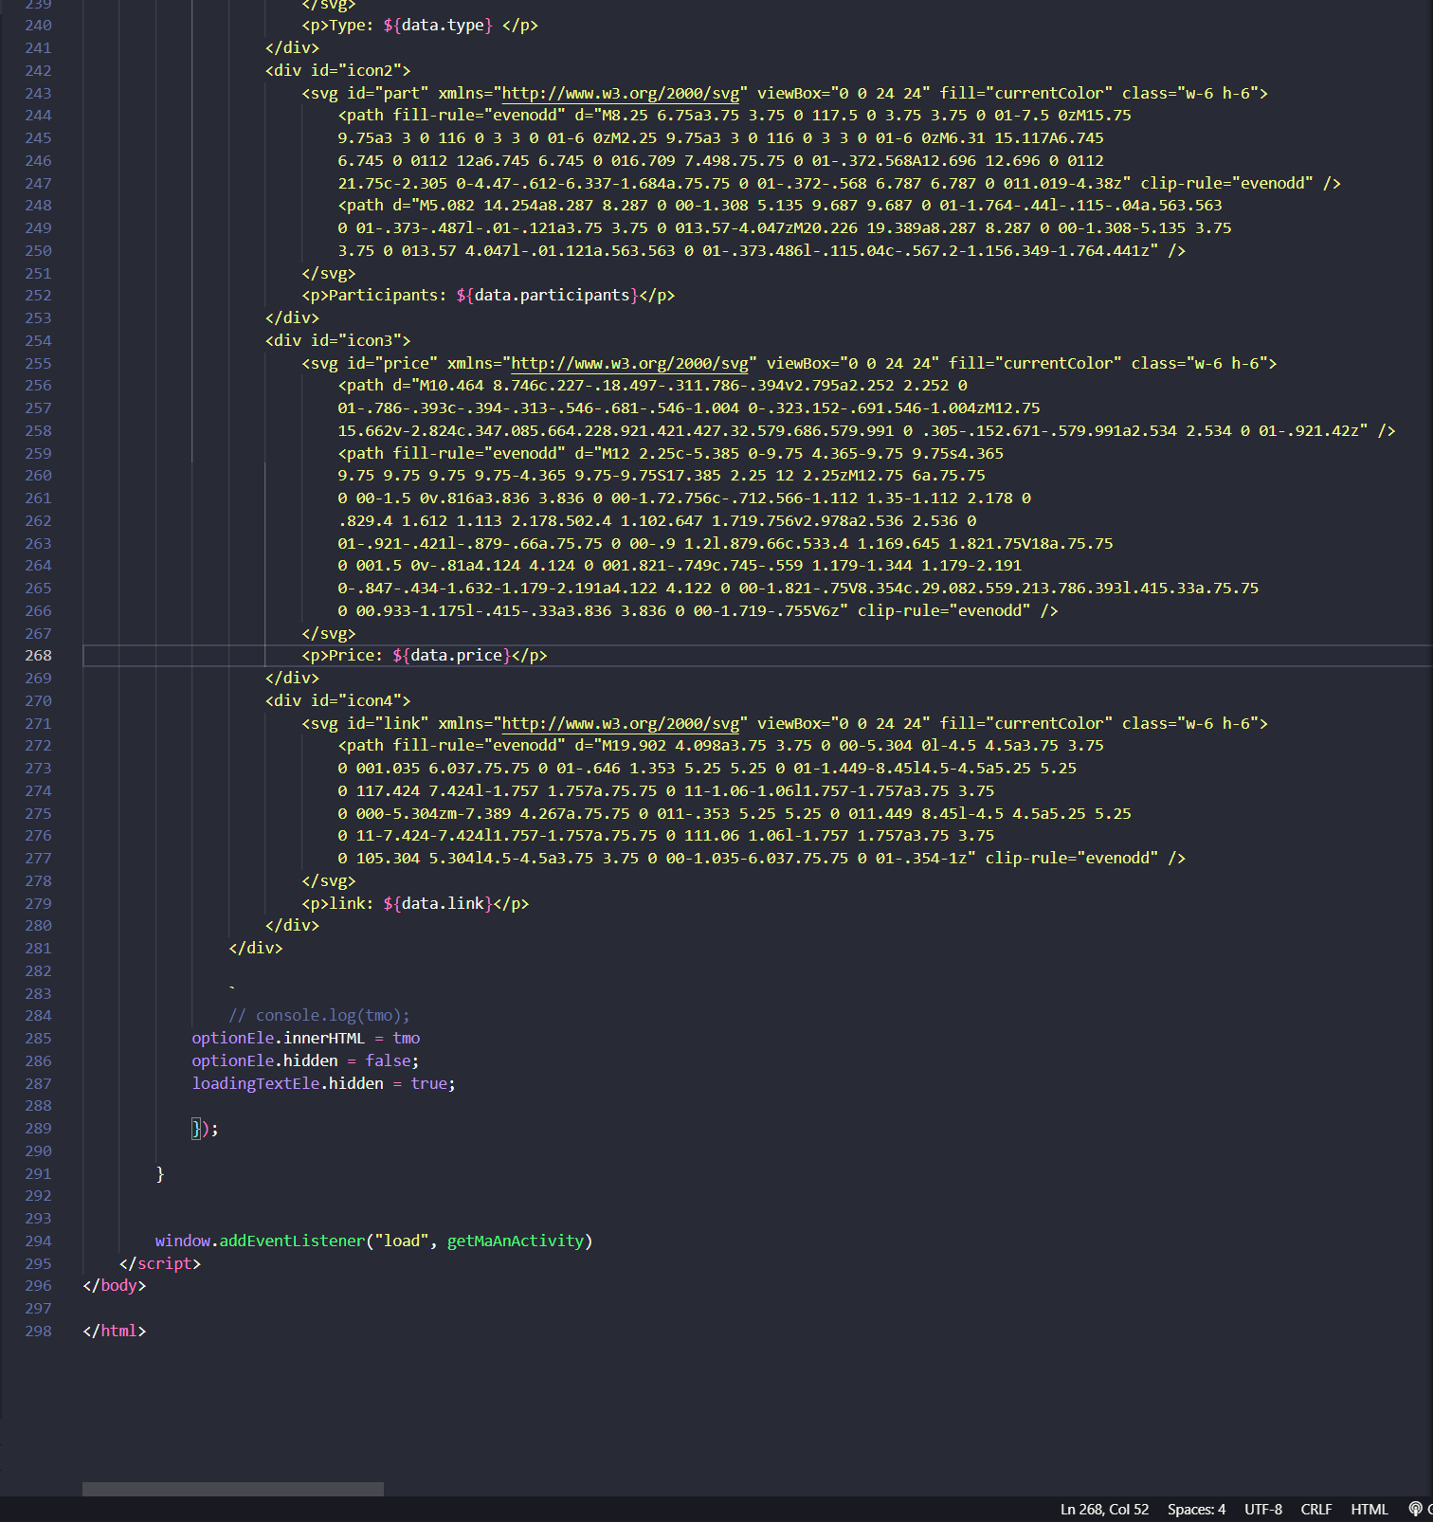

# Ex1-OUTPUT:

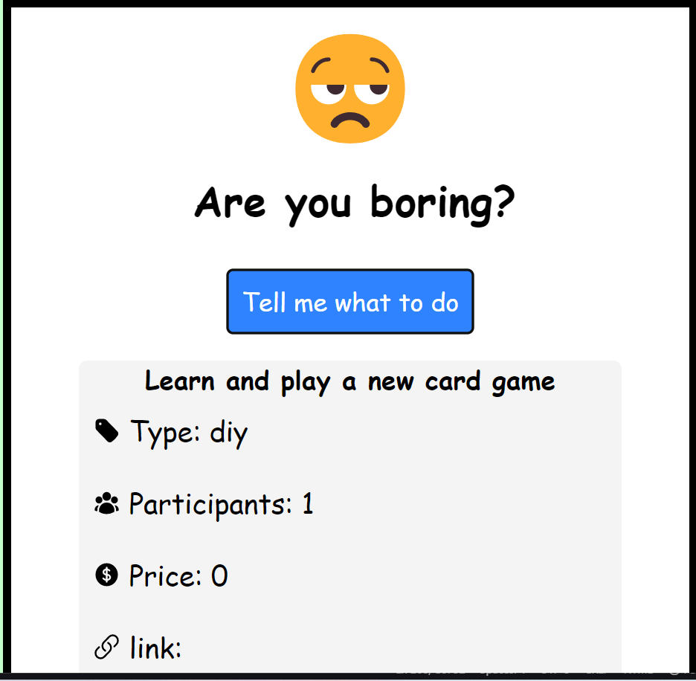

# Ex2:

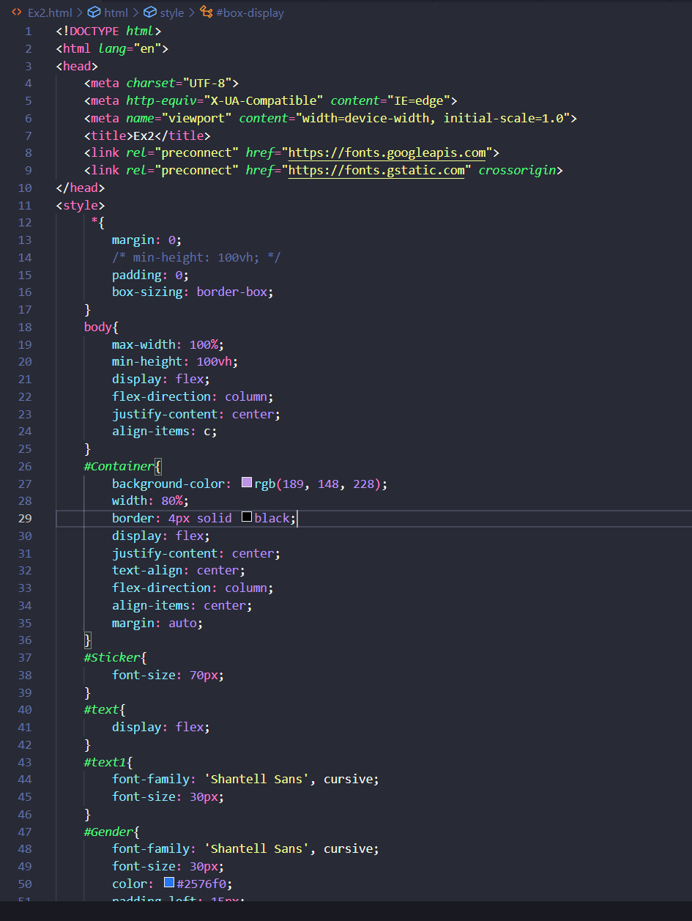

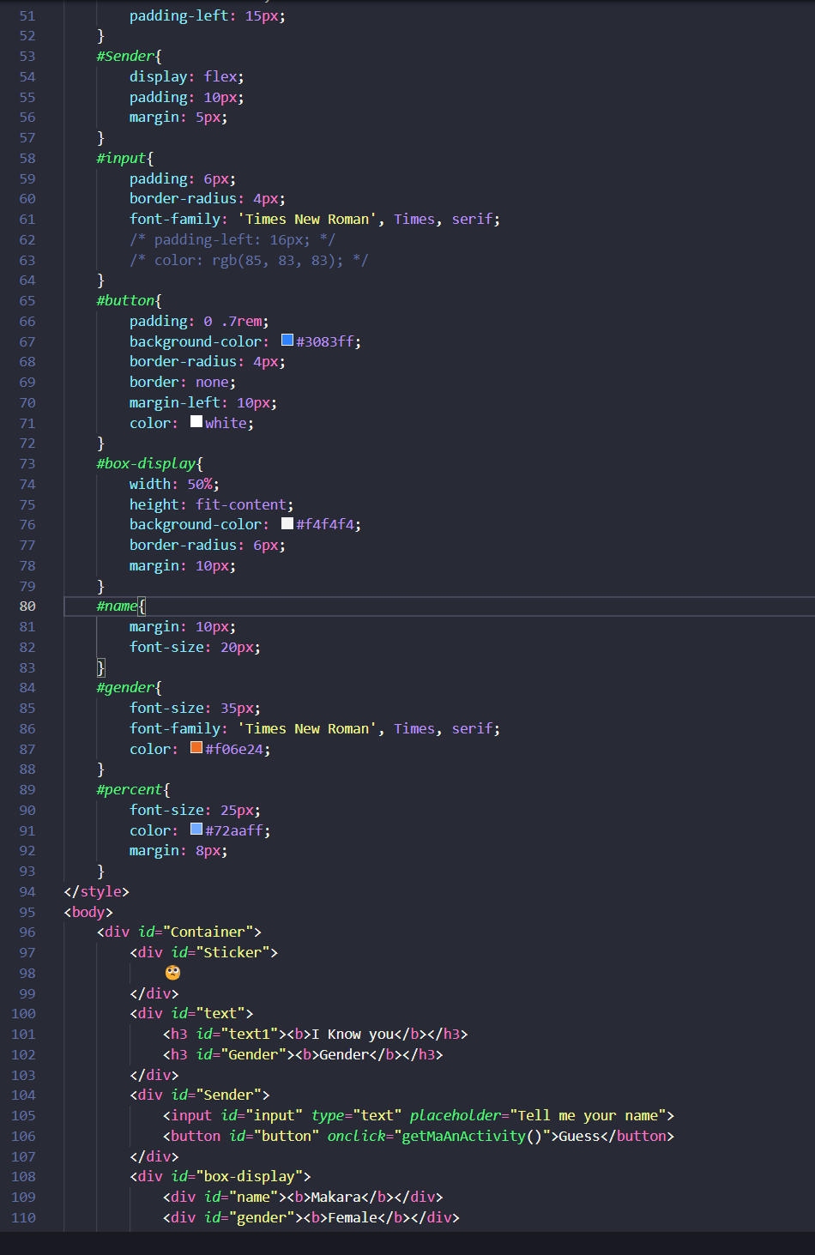

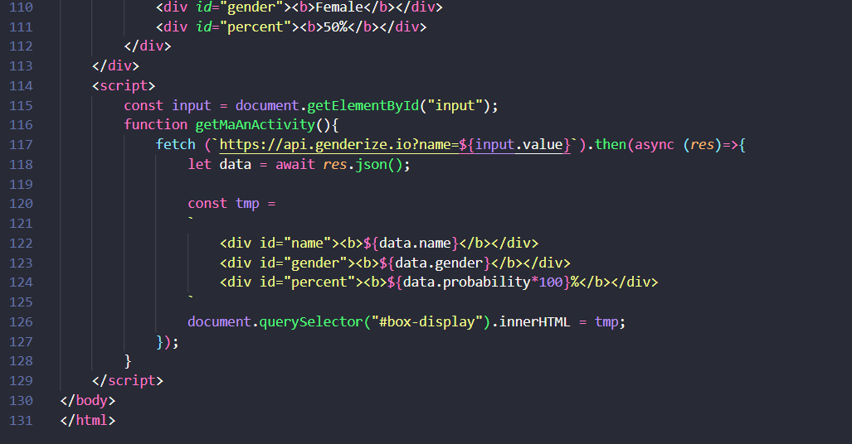

# Ex2-OUTPUT:

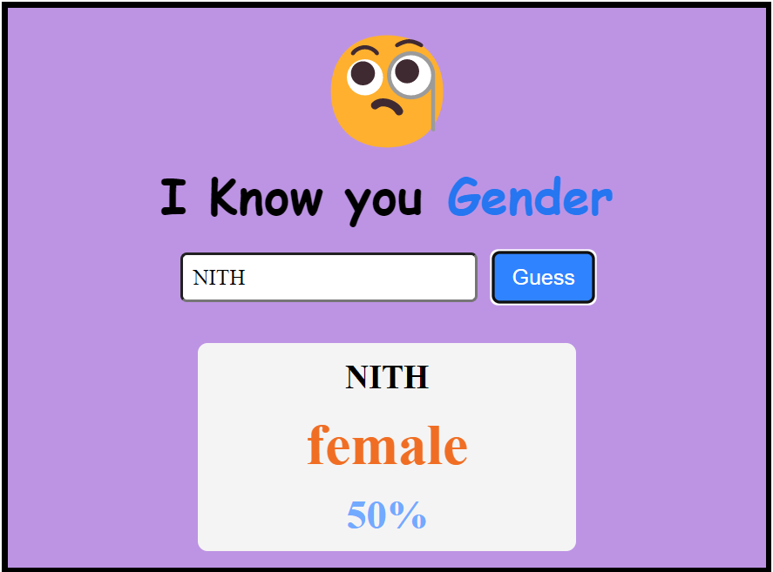

# EX3:

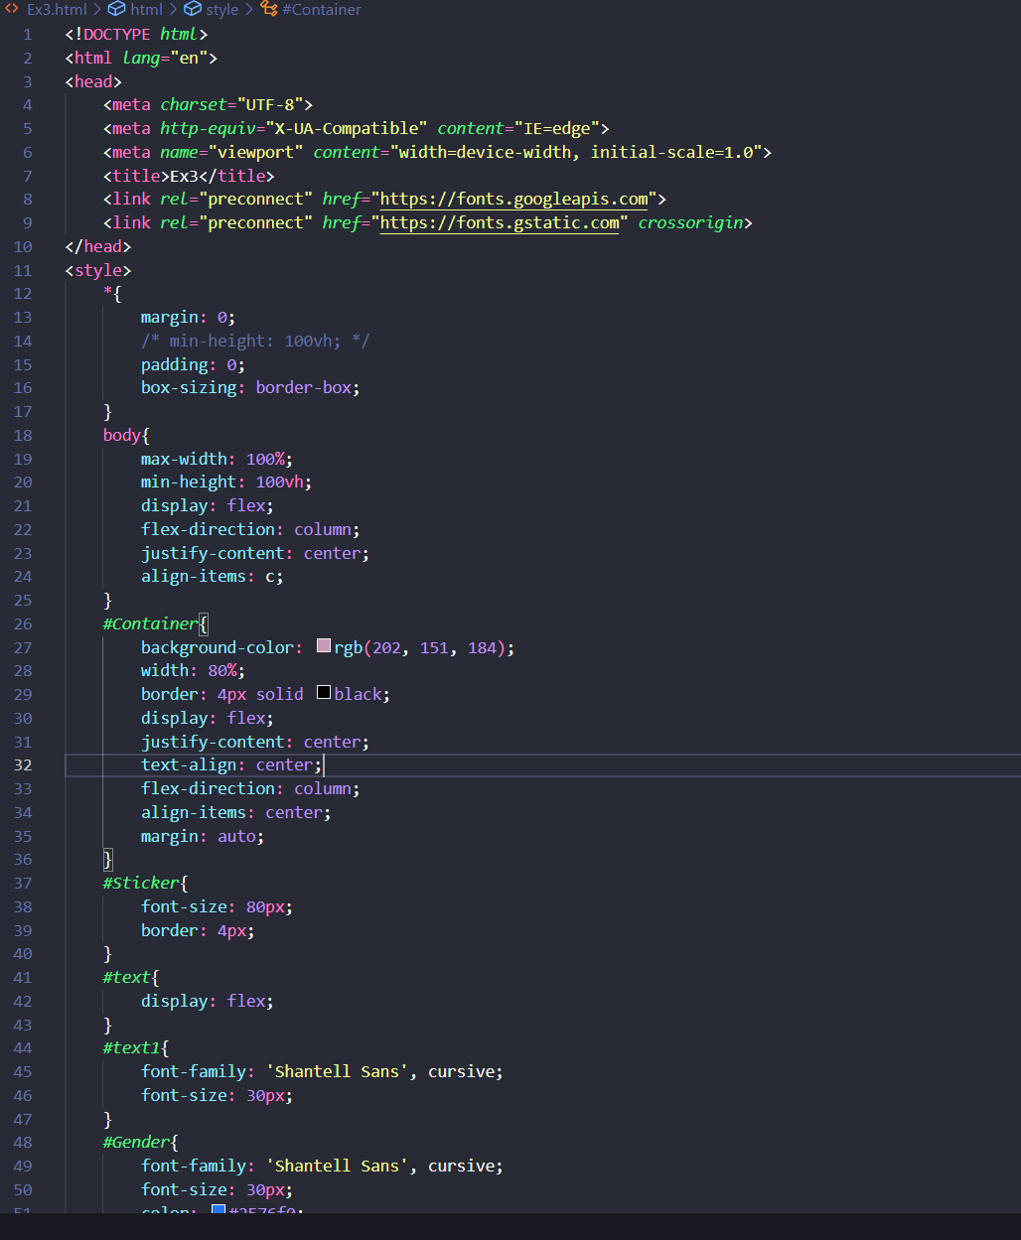

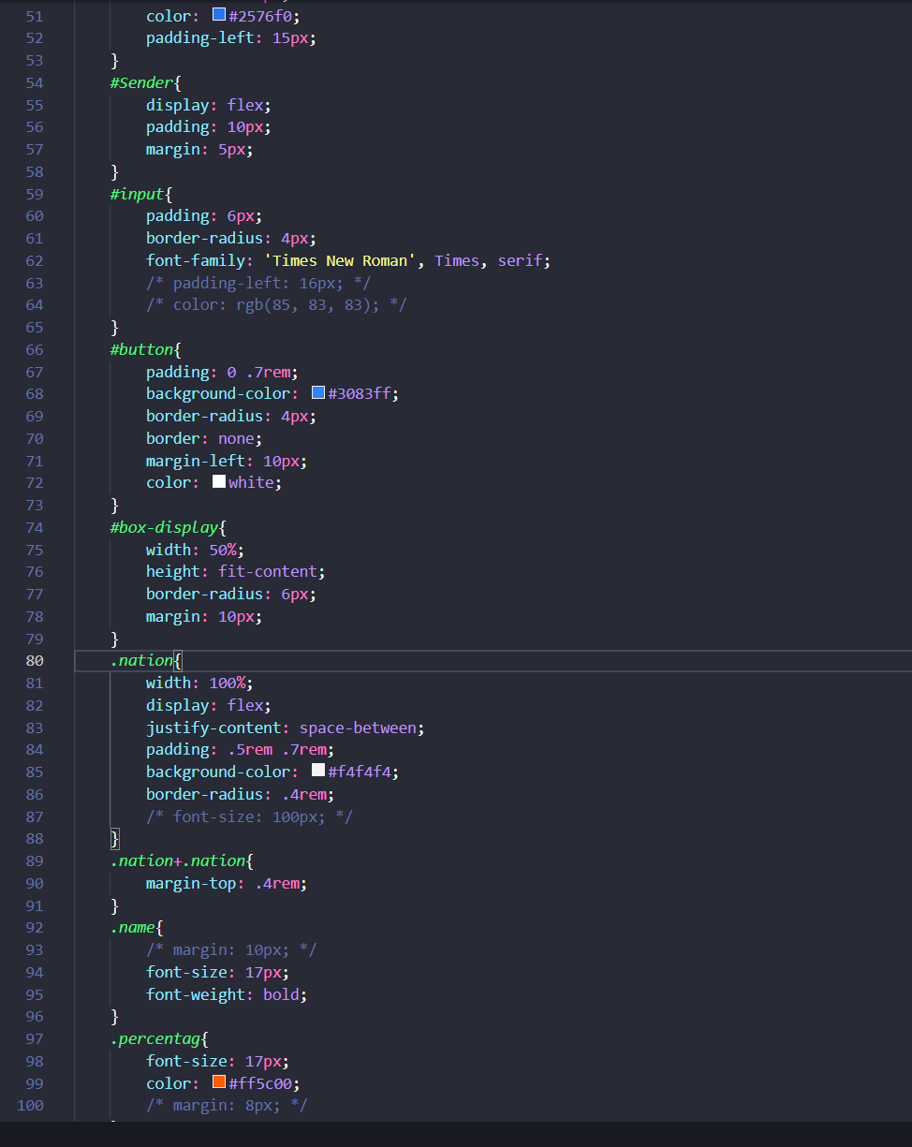

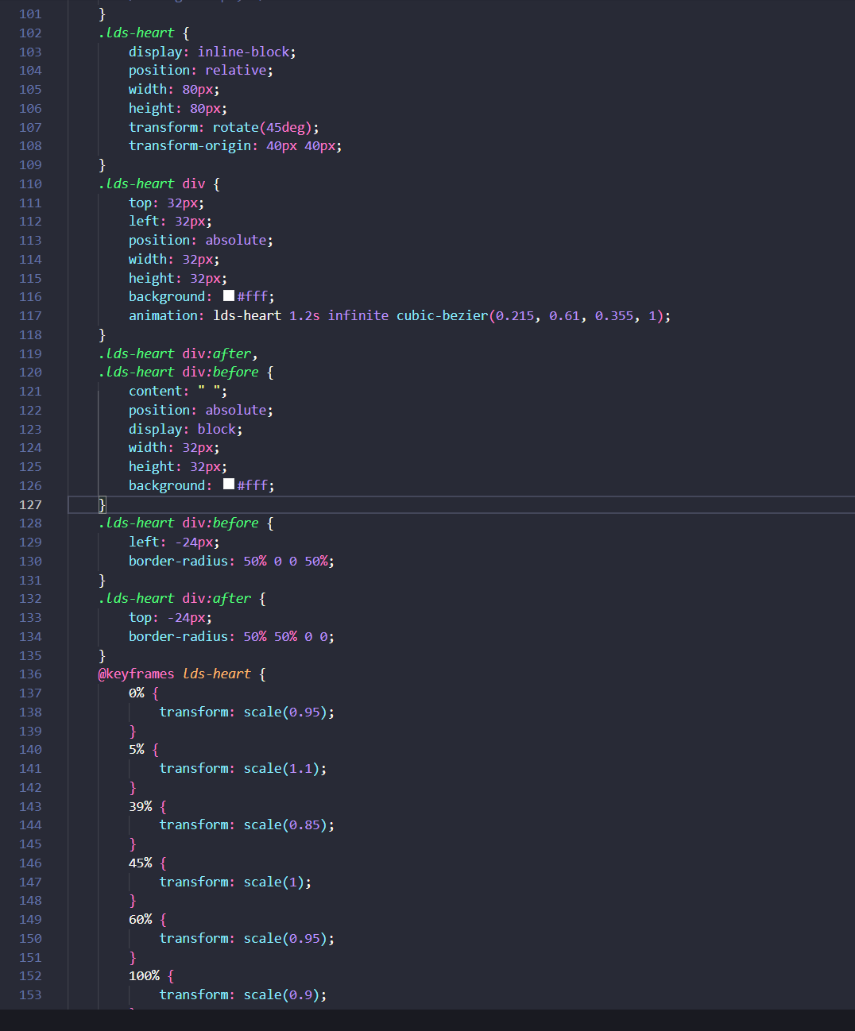

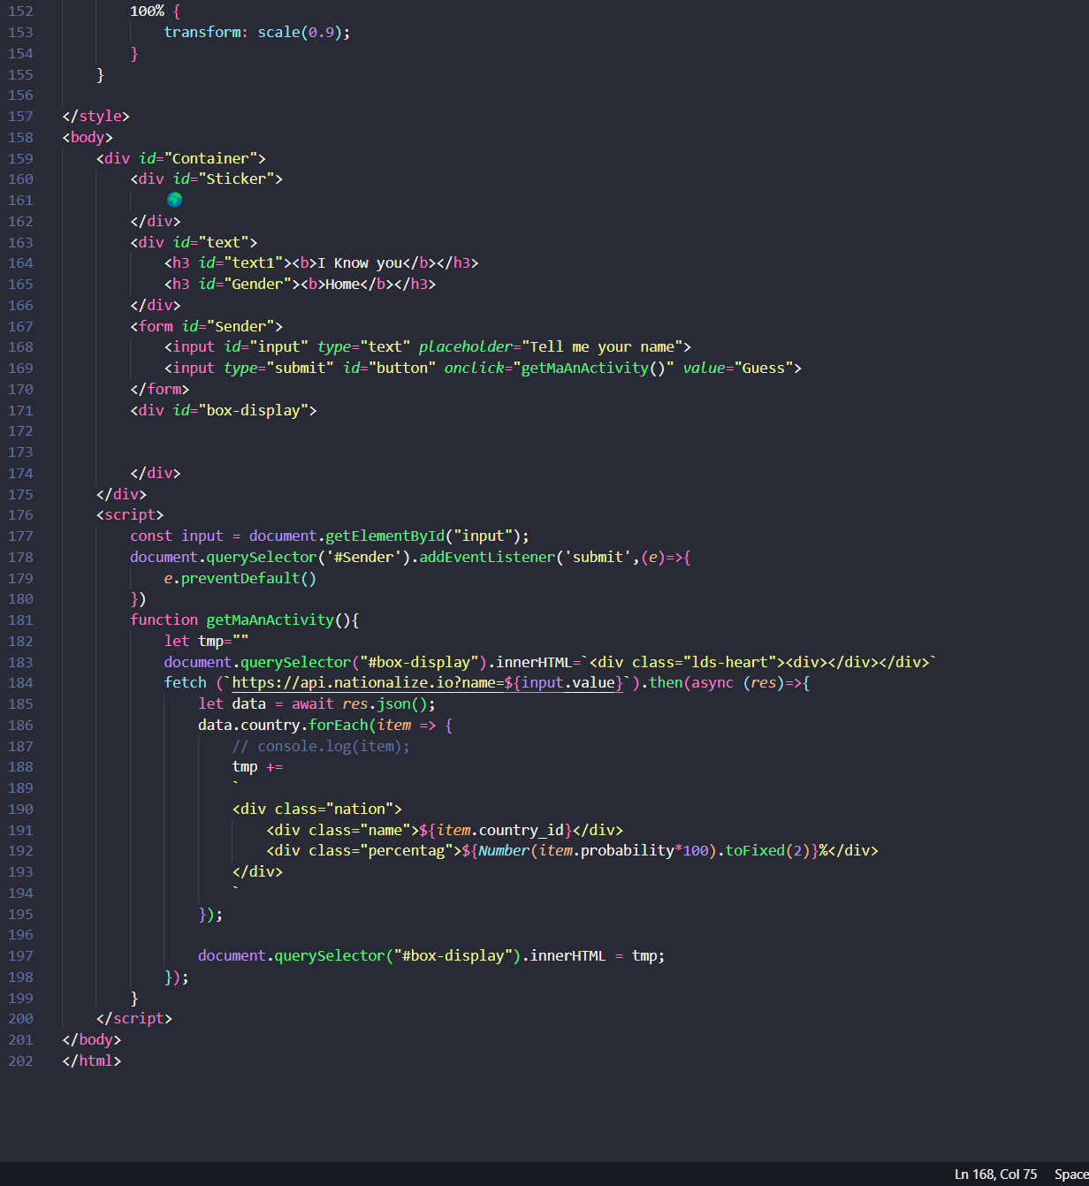

# Ex3-OUTPUT:

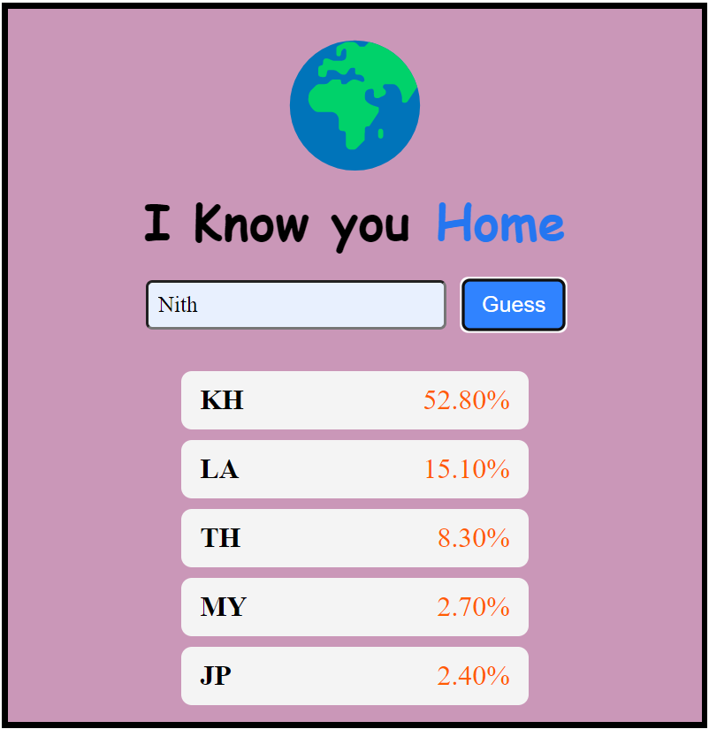

# EX4:

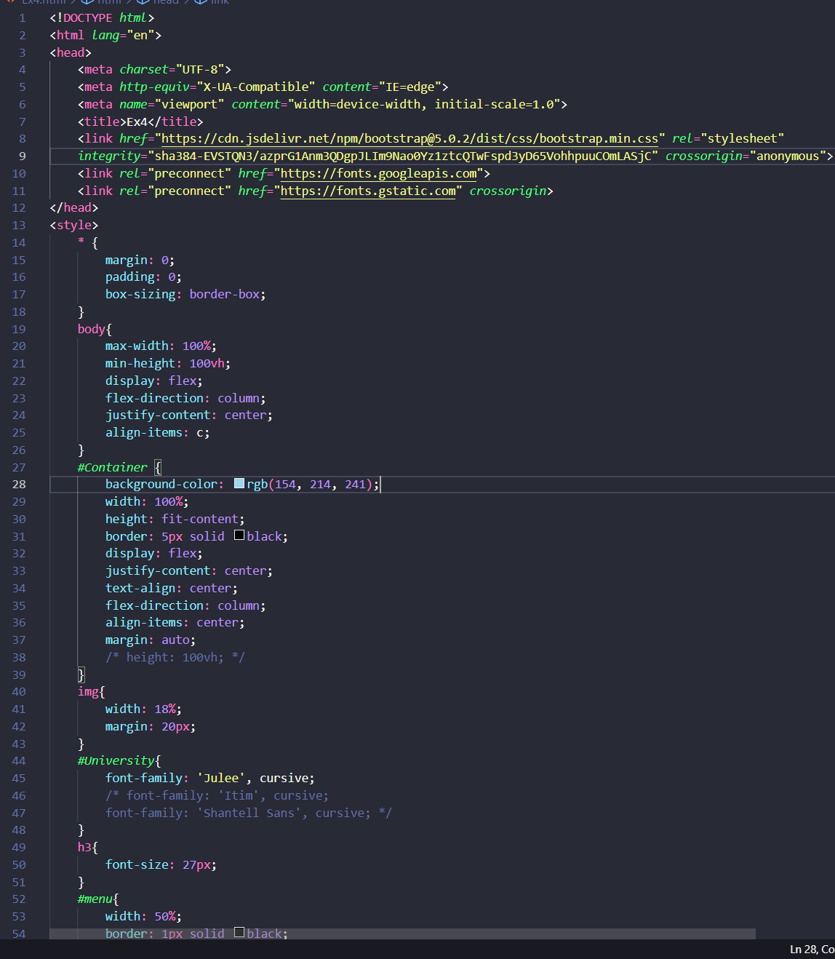

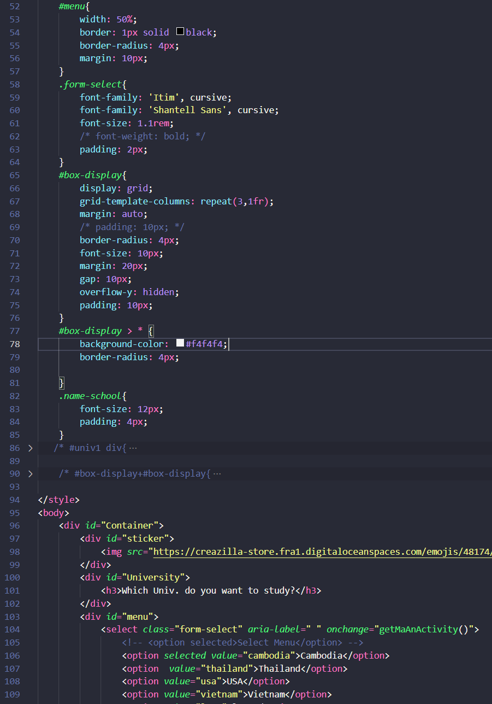

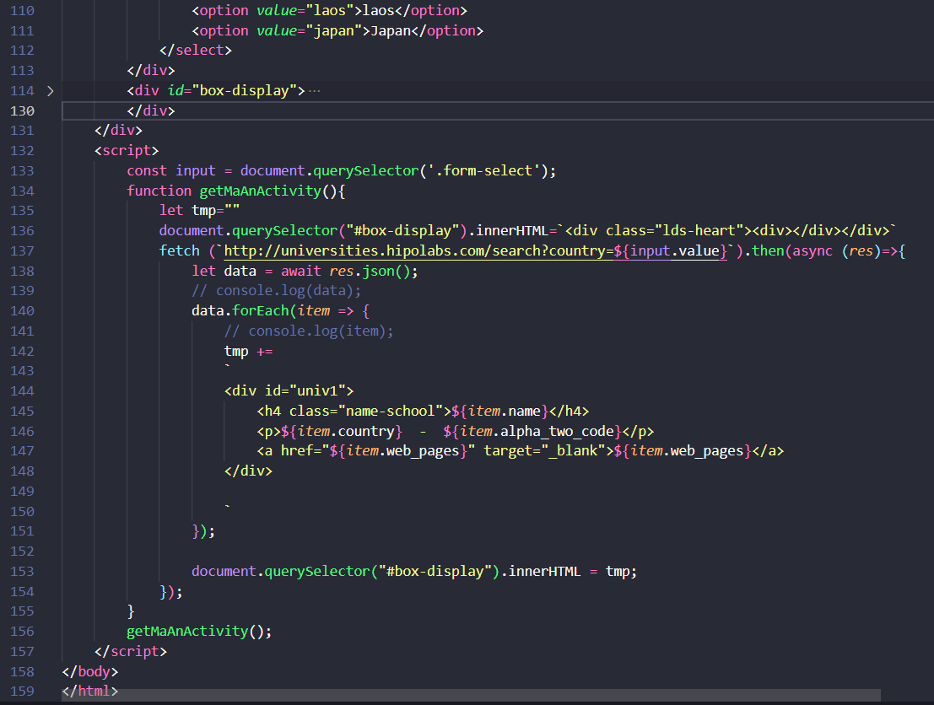

# Ex4-OUTPUT:

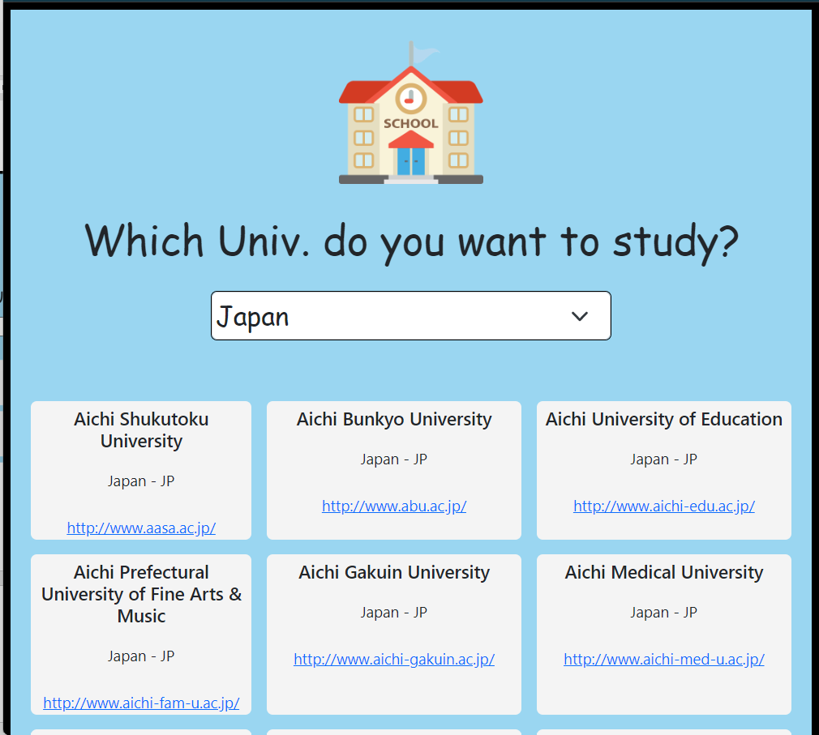

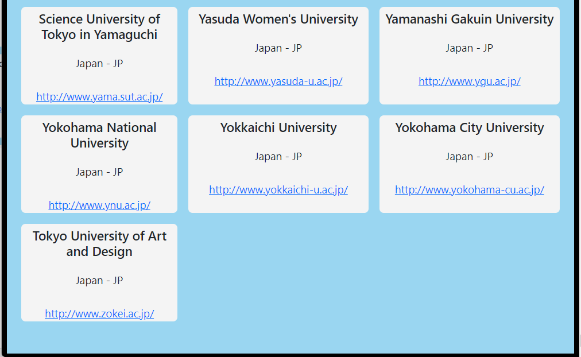

# EX5:

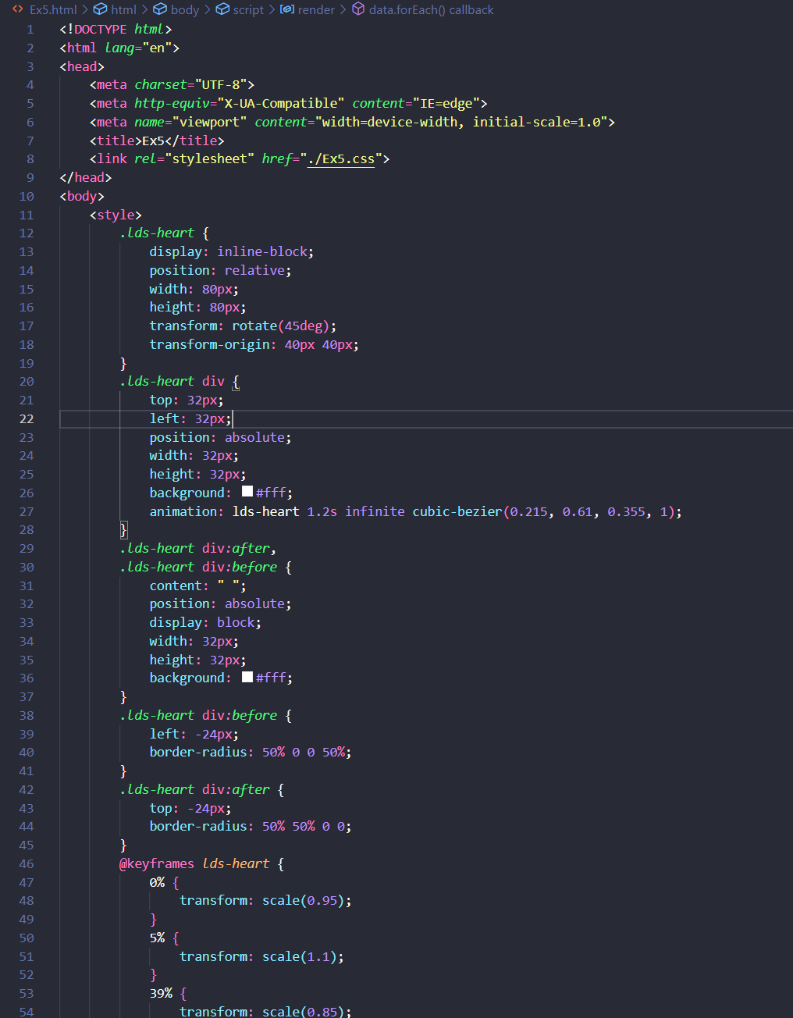

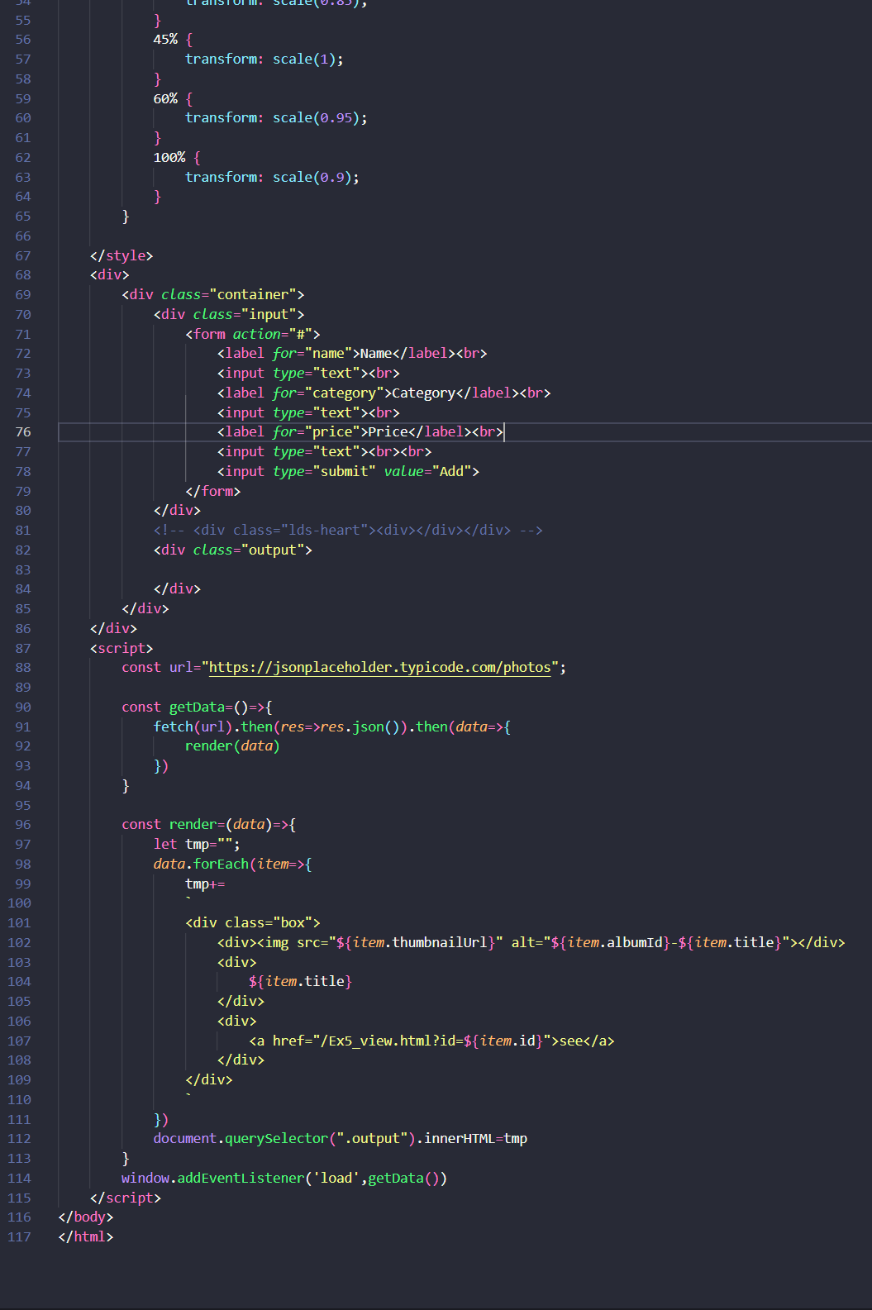

# CSS-EX5:

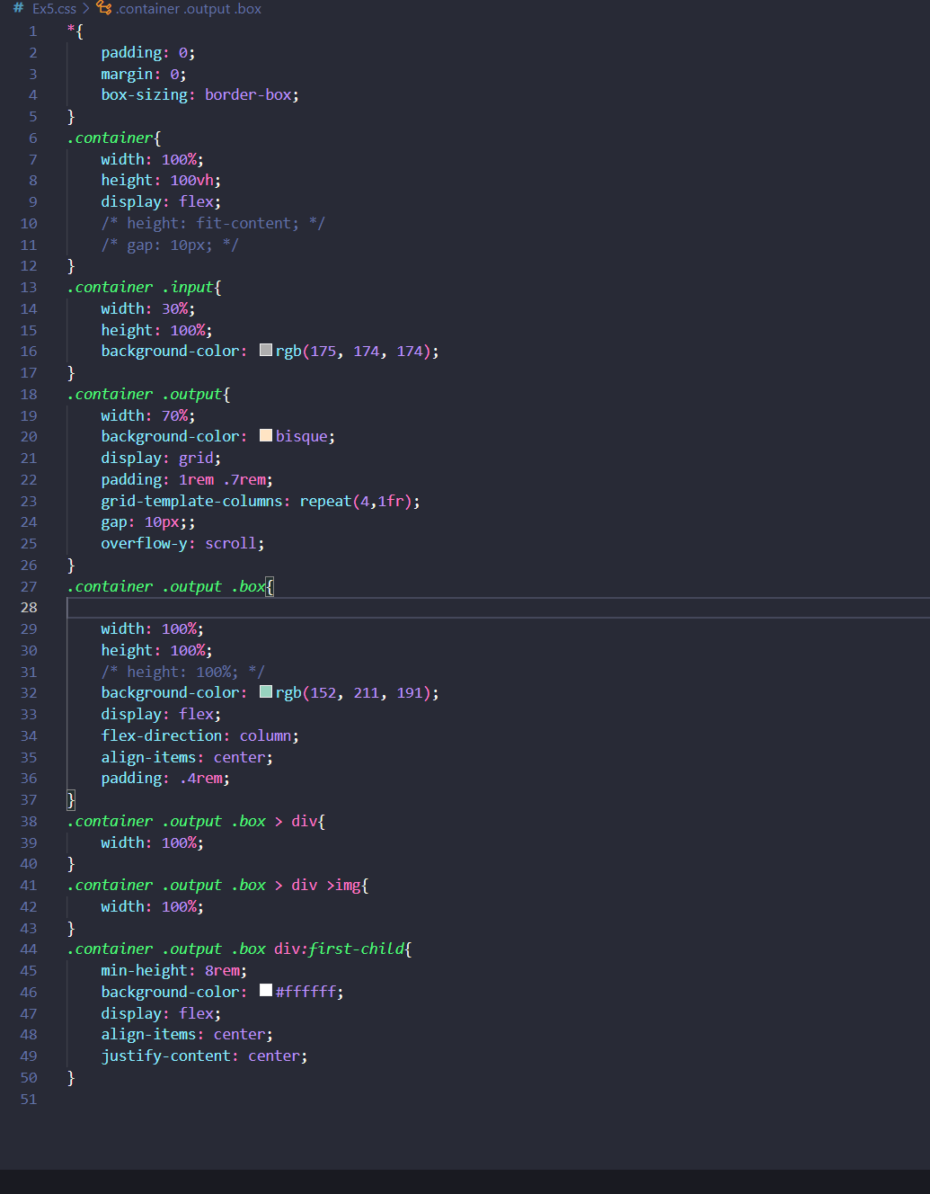

# EX5-view:

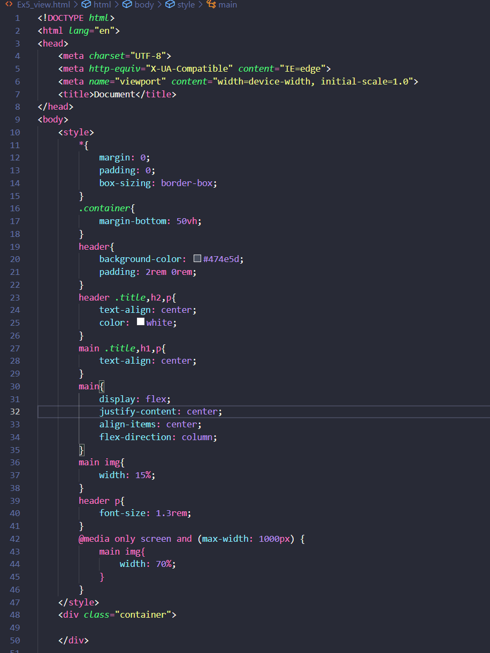

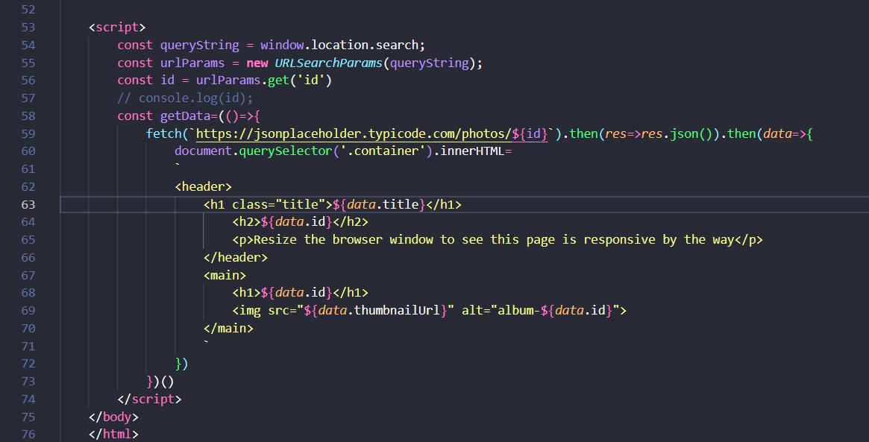

# Ex5-OUTPUT:



